**Critical Thinking 1 - C++ Console Application and Correcting Errors Screenshots**

Andrew Barnes

Colorado State University Global

CSC450-1

Reginald Haseltine

4/21/2024

**C++ application that prints a fictional person to the console**

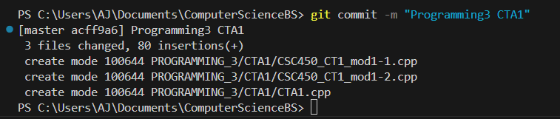

**CSC450_CT1_mod1-1.cpp source code correction and execution**

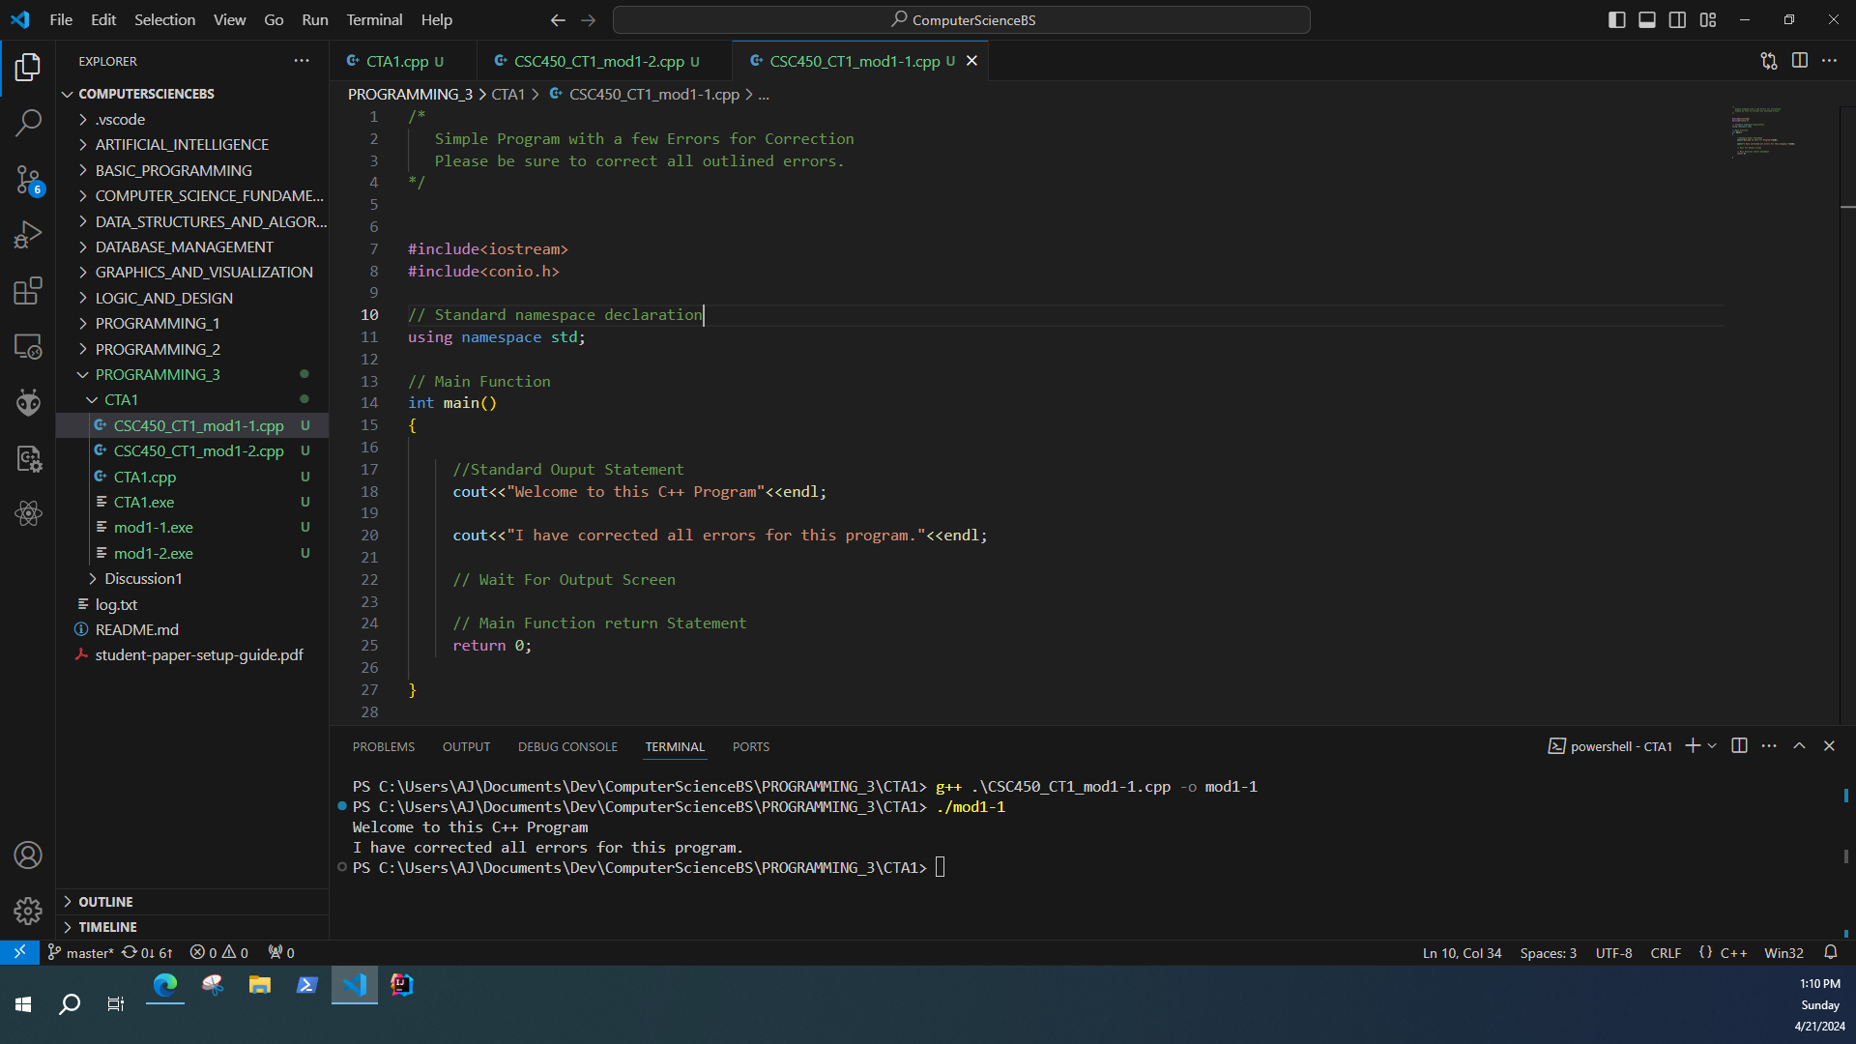

**CSC450_CT1_mod1-2.cpp source code correction and execution**

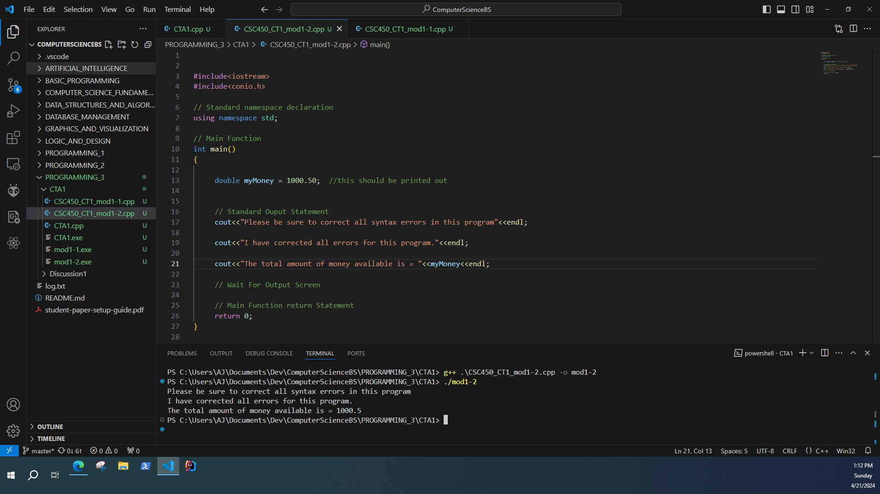

**Git Repository Commands**

